Free Legal Clinic
Expungement | Family| Immigration| Housing | Debt/Bankruptcy | Employment

Small Claims | Government Benefits | Probate | Small Business

Saturday, February 22, 2019

Registration Begins at 11:30 AM
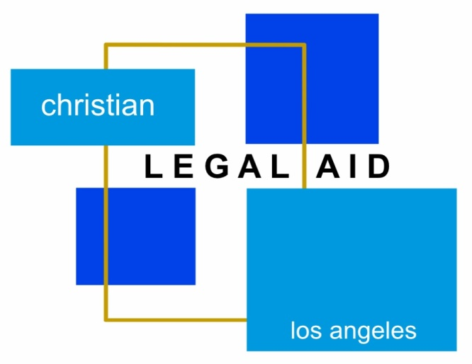

Free Legal Clinic will be held from 12 PM to 3PM. Come talk to a volunteer attorney about your legal issue!

REGISTRATION STARTS AT 11:30AM AND ENDS AT 1PM; LATE ARRIVALS MAY NOT BE SEEN
APPOINTMENTS REQUIRED!!

Bread of Life Church
2780 Lomita Blvd. Torrance, CA 90505
Bring ALL DOCUMENTS related to your issue. Your income must meet HCD’s very low income guidelines.
To see if you qualify and to make an appointment, please call (323) 319-3559 or email client@cla-la.org
CLA-LA FREE LEGAL CLINIC
(323)319-3559
February, 22, 2020
2780 Lomita Blvd
Torrance, CA 90505

January 18,2014
1760 N. Gower St., Hollywood, CA 90028

CLA-LA FREE LEGAL CLINIC
(323)319-3559
February, 22, 2020
2780 Lomita Blvd
Torrance, CA 90505

GAL CLINIC
(323)319-3559
January 18,2014
1760 N. Gower St., Hollywood, CA 90028

CLA-LA FREE LEGAL CLINIC
(323)319-3559
February, 22, 2020
2780 Lomita Blvd
Torrance, CA 90505

CLA-LA FREE LEGAL CLINIC
(323)319-3559
February, 22, 2020
2780 Lomita Blvd
Torrance, CA 90505

CLA-LA FREE LEGAL CLINIC
(323)319-3559
February, 22, 2020
2780 Lomita Blvd
Torrance, CA 90505

CLA-LA FREE LEGAL CLINIC
(323)319-3559
February, 22, 2020
2780 Lomita Blvd
Torrance, CA 90505

CLA-LA FREE LEGAL CLINIC
(323)319-3559
February, 22, 2020
2780 Lomita Blvd
Torrance, CA 90505

CLA-LA FREE LEGAL CLINIC
(323)319-3559
February, 22, 2020
2780 Lomita Blvd
Torrance, CA 90505

