PROGRAMS  Types of Programs Offered:  - Summer Internships  - Fall & Spring Internships  - Post Graduate Clerkships  - Legal Team Volunteers  - Helpline Volunteers  Summer Program:  May 17 – July 23, 2021  - 35 hours per week  - Based in Inglewood  - Send cover letter, resume, and list of references to carolyn@cla-la.org  Fall/Spring Program:  - 4 to 16 hours a week  - Location Varies  - Email carolyn@cla-la.org if interested  Post-Graduate Program:  Email carolyn@cla-la.org for more information.  Clinic Volunteers:  Ongoing. Email volunteer@cla-la.org for more information.  OFFICE INFORMATION  (323) 319-3559  333 W. Florence Ave. Inglewood, CA 90301  http://www.cla-la.org  CONTACT  Carolyn Jefferson  Director of Legal Programs  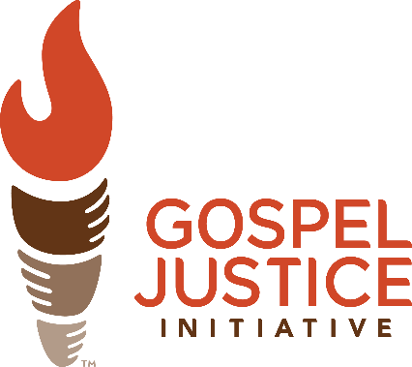  carolyn@cla-la.org  (323) 319-3559 | MISSION STATEMENT  CLA-LA’s mission is to share the love of Jesus Christ by cultivating a passion for justice in our community and providing free legal services and hope to those in need in Los Angeles County.  In 2019, the State Bar projected that low-income Californians would seek legal aid for approximately 450,000 civil legal problems; but only 1/3 of those would receive legal aid. The staggering difference between the supply of legal aid and the need for help is called the "justice gap."  This gap means that our most vulnerable citizens have no access to justice. The Bible tells us in over 2,000 verses to protect the rights of all who are destitute. At CLA-LA, we believe that we must find ways to follow through on this mandate and our national pledge to provide "justice for all."  CLA-LA seeks to bridge the “justice gap” through legal urgent care clinics - a first stop on the road toward justice. Working with volunteers and local churches, CLA-LA uses this model to offer free legal clinics throughout LA County. | INTERNSHIP DESCRIPTION  CLA-LA’s internship offers the following learning opportunities:  - Interns will be trained in the skills of a “can-do” attorney.  - Interns will learn the fundamentals of team building, interviewing clients, communicating with supervising attorneys, and serving clients.  - Interns will become subject matter experts in an area of law of their choosing, working under an experienced attorney, and train volunteer lawyers in that area.  - Interns will take field trips to learn about barriers to justice and to visit local judges and lawyers.  - Interns will learn about running a non-profit, including partnership building with our charity partners.  - Interns will learn about the business of operating a law firm and/or the spiritual development of Christian-based legal services.  1 in 3 Americans  cannot afford an attorney
 | PRACTICE AREAS  CLA-LA assists clients with many legal issues including expungement; family law; housing; immigration; government benefits; bankruptcy; employment law; small claims; and wills/probate.  CLA-LA refers out matters that require ongoing representation. | HIRING CRITERIA  Interns should demonstrate a passion for the vision that drives CLA-LA. Experience working with non-profit organizations, low-income communities, and direct client services is preferred. Interns will be expected to take on leadership responsibilities, engage in self-directed research and writing, and demonstrate flexibility to serve in various roles as needed.

