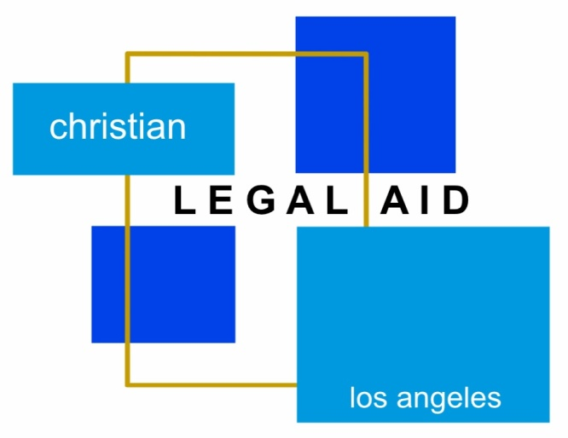
Free Legal Phone Clinic
Expungements (Criminal Case History is Needed) | Family Law | Immigration| Housing | Debt/Bankruptcy | Employment
Small Claims | Government Benefits | Probate | Small Business
Free Telephone Legal Clinic
Saturday, November 20, 2021

Talk to an Attorney about your legal issue!
Free Telephone Clinic will run from 1:00 PM to 4:00 PM.

Pre-Registration will end on Friday, November 12, 2021 at 12pm.
Please call the office at 323.319.3559 to do an intake over the phone.
Your income must meet HCD’s very low-income guidelines.
To see if you qualify, call (323) 319-3559 or visit our website at CLA-LA.org.

Please email ALL DOCUMENTS related to your issue to
chrystal@cla-la.org prior to the telephone clinic.

