Dear friend,

I am hosting a table at Christian Legal Aid of Los Angeles’s 11th Annual Prayer Breakfast, and I would love for you to join me there!

The prayer breakfast will be held on November 11, 2017, from 9:00am to 11:00am, in the conference room at the Cathedral of Our Lady of the Angels.
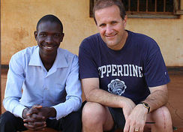
This year, the keynote speaker at CLA-LA’s prayer breakfast will be Jim Gash. Jim is a Professor of Law at Pepperdine University School of Law and serves as Director of the Global Justice Program. Jim’s book “Divine Collision: An African Boy, An American Lawyer, and Their Remarkable Battle for Freedom” was published in 2016.

The prayer breakfast is free thanks to CLA-LA’s sponsors. Childcare will be provided. Parking is available at the Cathedral of Our Lady of the Angels at a nominal cost. The nearest metro stop is the Civic Center/Grand Park station about two blocks away.

Please let me know as soon as possible if you plan to attend so that CLA-LA can ensure seating and food for all guests.

Donations of any amount will be welcomed at the event. If you are interested in sponsoring the prayer breakfast, you can email CLA-LA directly at pb2017@cla-la.org. Sponsor packages range from $300-$5000 and include a sponsor listing in the program.

I hope you will join me on November 11th!

Best,

