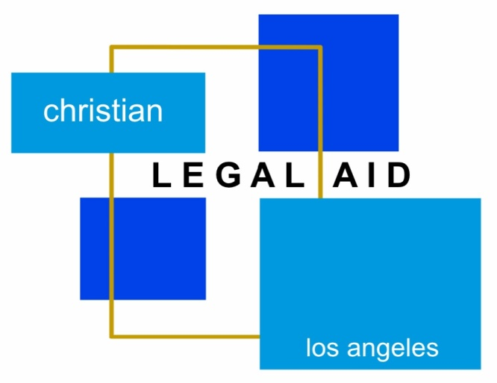
Free Legal
Aid Clinic
Expungements (Criminal Case History is Needed) | Family Law | Immigration| Housing | |Debt/Bankruptcy | Employment |
|Small Claims | Government Benefits | Probate | Small Business|
Free Legal Aid Clinic
Saturday, January 21, 2023
Location: Faithful Central Bible Church in the Trinity Building on Level A.

Talk to an Attorney about your legal issue!

Free Legal Aid Clinic will run from 11:00 AM to 3:00 PM.

Pre-Registration will end on Friday, January 13, 2023 at 12pm.
Please call the office at 323.319.3559 to do an intake over the phone.

Your income must meet HCD’s very low-income guidelines.
To see if you qualify, call (323) 319-3559 or visit our website at CLA-LA.org.

Please email ALL DOCUMENTS related to your issue to
chrystal@cla-la.org prior to the clinic.

