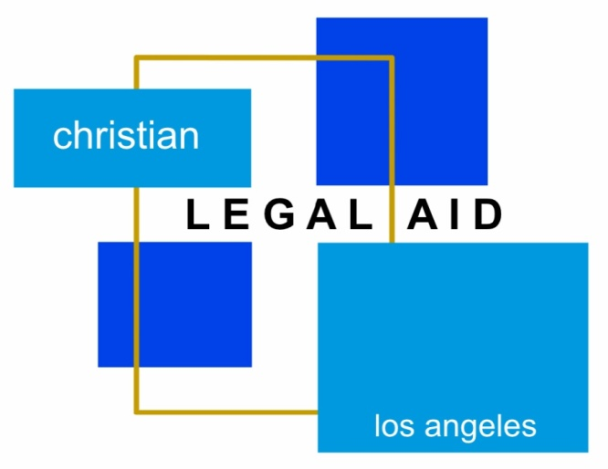
Free Legal Aid
Phone Clinic
Expungements (Criminal Case History is Needed) | Family
| Immigration|Housing | Debt/Bankruptcy | Employment ||Small Claims |
Government Benefits | Probate | Small Business|
Free Legal Aid Phone Clinic
Saturday, June 17, 2023

Talk to an Attorney about your legal issue!

Free Legal Aid Phone Clinic will run from 1:00 PM to 4:00 PM.

Pre-Registration will end on Wednesday, Juen 7, 2023 at 12pm.
Please call the office at 323.319.3559 to do an intake over the phone.

Your income must meet HCD’s very low-income guidelines.
To see if you qualify, call (323) 319-3559 or visit our website at CLA-LA.org.

Please email ALL DOCUMENTS related to your issue to
chrystal@cla-la.org prior to the clinic.

